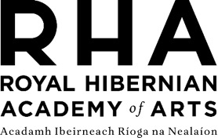

RHA Kids - Parent/ Guardian Consent Form
Workshop Details

Workshop Title:
Date:

Participant Details

First name:
Surname:

Date of Birth:

Parent/ Guardian Details

First name:
Surname:

Email:
Contact number (during time of workshop):

Secondary Emergency Contact (Name and Contact number):
Name and contact details of person who is to collect child/ young person from workshop (if this is not you):
Please provide information of any medical conditions, allergies or special needs/ learning requirements your child may have that we should be aware of:

I give consent for photographs of my child to be taken during this workshop (to be used for promotion/online etc.) Yes No (Please circle the appropriate answer)
I give consent for my child to participate in the workshop, as outlined above, at the RHA Gallery . Yes No (Please circle the appropriate answer)
Print name: Signature:

Date:

Please return completed form to: Front of House, RHA Gallery, 15 Ely Place, Dublin 2 Tel: 01 661 2558, ciara@rhagallery.ie

